1) KPI’s
1. Total Revenue
SELECT SUM (total_price) AS total_revenue
FROM pizza_sales;

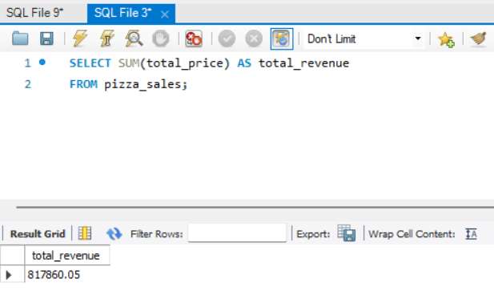

2. Average Order Value
SELECT ROUND(SUM(total_price) / COUNT(DISTINCT order_id), 2) AS avg_order_value
FROM pizza_sales;

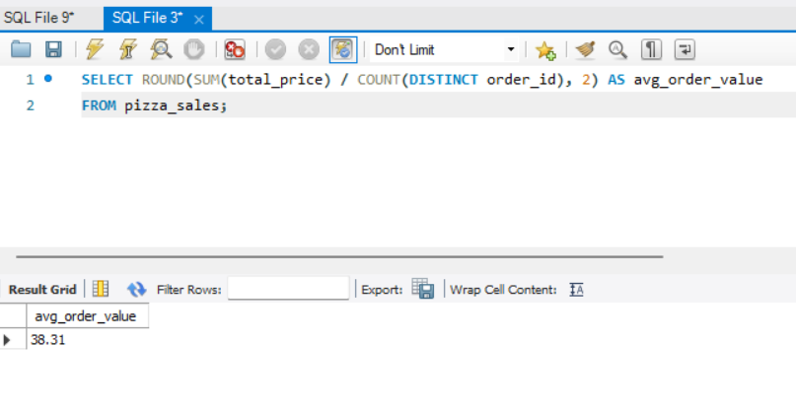

3. Total Pizzas Sold
SELECT SUM(quantity) AS total_pizzas_sold
FROM pizza_sales;

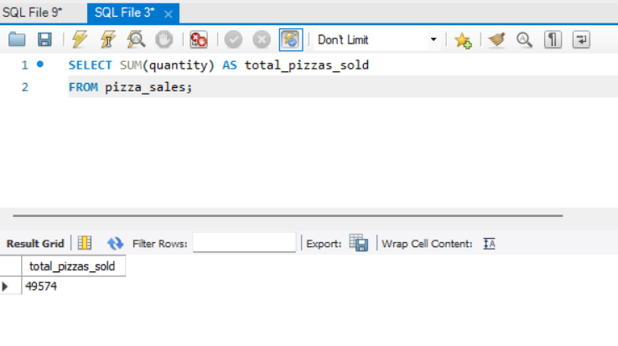

4. Total Orders
SELECT COUNT(DISTINCT order_id) AS total_orders
FROM pizza_sales;

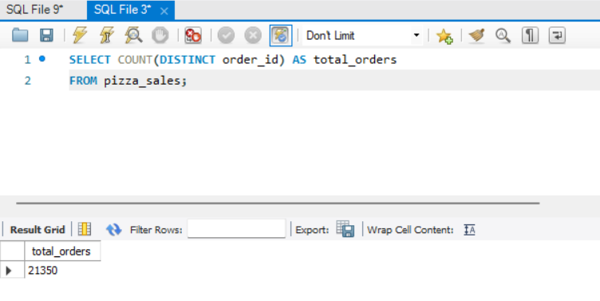

5. Average Pizzas Per Order
SELECT ROUND(SUM(quantity) / COUNT(DISTINCT order_id), 2) AS avg_pizzas_per_order
FROM pizza_sales;

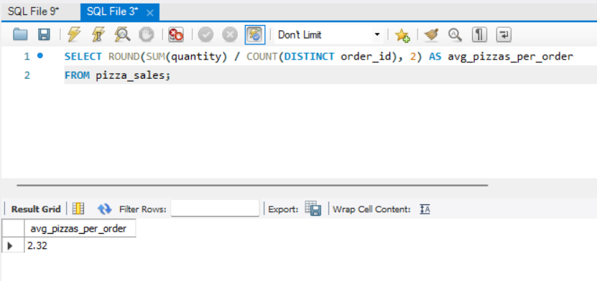

B. Daily Trend for Total Orders
SELECT DAYNAME(order_date) AS order_day,
COUNT(DISTINCT order_id) AS total_orders
FROM pizza_sales
GROUP BY DAYNAME(order_date)
ORDER BY total_orders DESC;

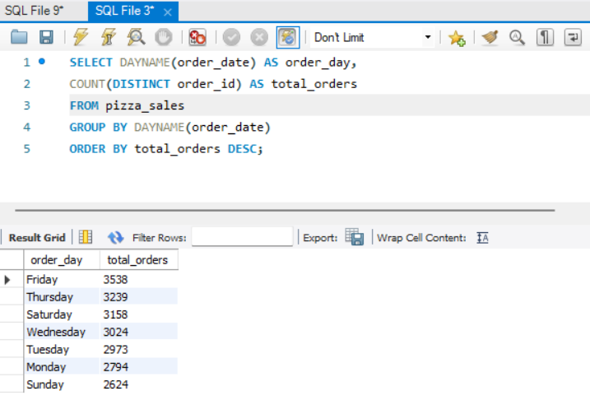

C. Hourly Trend for Orders
SELECT HOUR(order_time) AS order_hour,
COUNT(DISTINCT order_id) AS total_orders
FROM pizza_sales
GROUP BY HOUR(order_time)
ORDER BY order_hour;

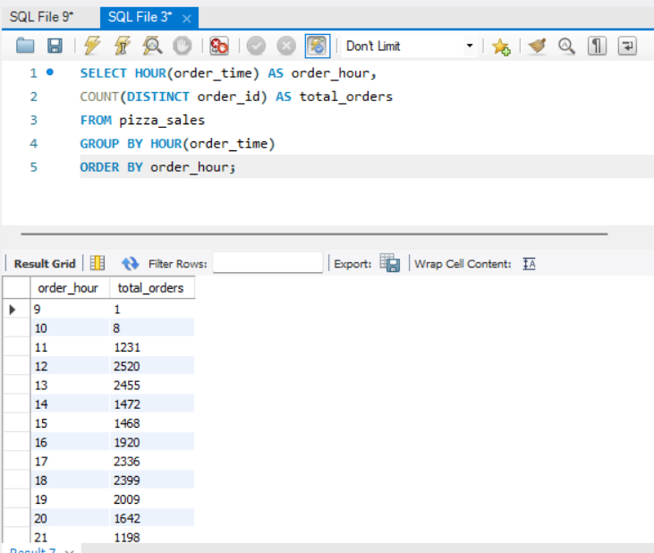

D. % of Sales by Pizza Category
SELECT pizza_category,
ROUND(SUM(total_price), 2) AS total_revenue,
ROUND(SUM(total_price) * 100 /
(SELECT SUM(total_price) FROM pizza_sales), 2) AS pct_sales
FROM pizza_sales
GROUP BY pizza_category
ORDER BY pct_sales DESC;

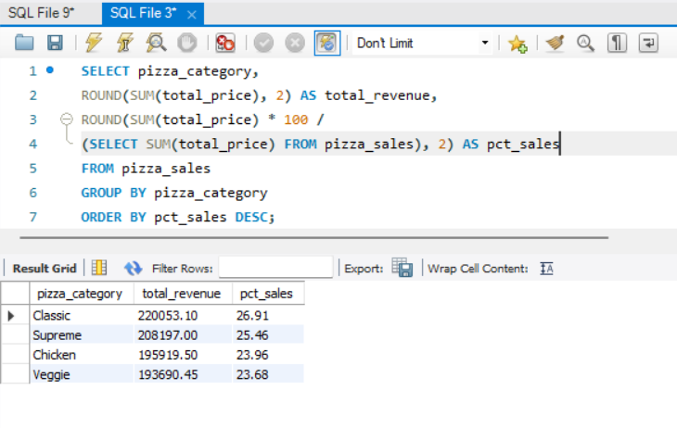

E. % of Sales by Pizza Size

SELECT pizza_size,
ROUND(SUM(total_price), 2) AS total_revenue,
ROUND(SUM(total_price) * 100 /
(SELECT SUM(total_price) FROM pizza_sales), 2) AS pct_sales
FROM pizza_sales
GROUP BY pizza_size
ORDER BY pct_sales DESC;

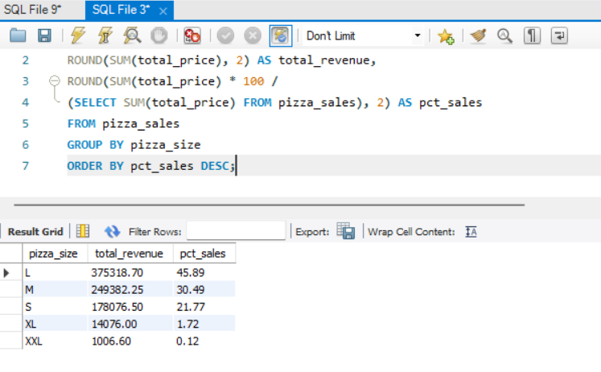

F. Total Pizzas Sold by Pizza Category
SELECT pizza_category,
SUM(quantity) AS total_quantity_sold
FROM pizza_sales
WHERE MONTH(order_date) = 2
GROUP BY pizza_category
ORDER BY total_quantity_sold DESC;

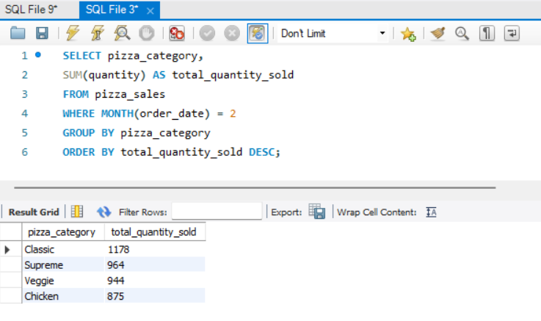

G. Top 5 Best Sellers by Total Pizzas Sold
SELECT pizza_name,
SUM(quantity) AS total_pizza_sold
FROM pizza_sales
GROUP BY pizza_name
ORDER BY total_pizza_sold DESC
LIMIT 5;

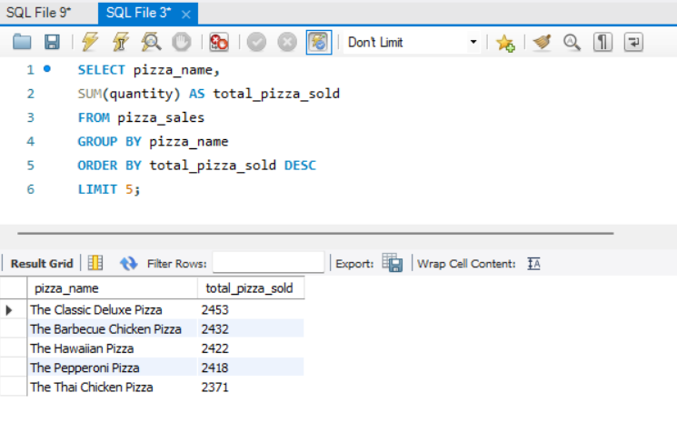

H. Bottom 5 Best Sellers by Total Pizzas Sold
SELECT pizza_name,
SUM(quantity) AS total_pizza_sold
FROM pizza_sales
GROUP BY pizza_name
ORDER BY total_pizza_sold ASC
LIMIT 5;

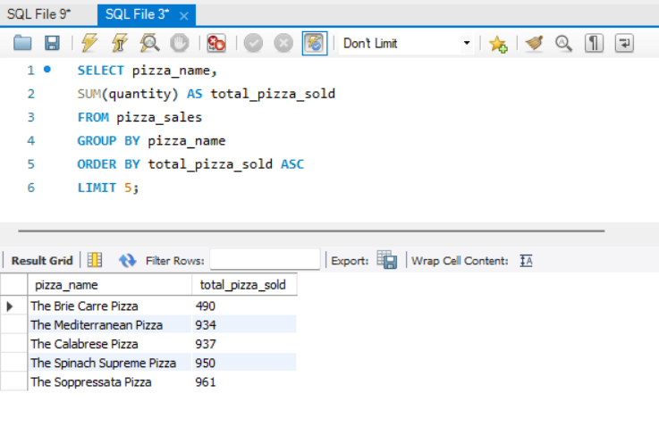

Monthly Filter Example
SELECT DAYNAME(order_date) AS order_day,
COUNT(DISTINCT order_id) AS total_orders
FROM pizza_sales
WHERE MONTH(order_date) = 1
GROUP BY DAYNAME(order_date);

